**Slope, Linear Equations, Proportions**  Name ________________



***Slope = Rise / Run***

**Slope Multiple Choice** – select the best answer.



______ 1. Every linear graph has a slope whose units are in the form of:

A) x unit / y unit B) y unit / x unit C) x unit * y unit D) slope never has units in this class



______ 2. On a position time graph, which of these will tell you how fast the object is moving?

A) x-intercept B) y-intercept C) slope D) impossible to read from a PT graph



______ 3. The correct y = mx + b form for a y-intercept of 8 and a slope of 3 would be:



A) y = 3x + 8 B) y = 8x +3 C) 3 = m8 + b D) 8 = m3 + b



______ 4. A graph that has a negative slope looks like a line that:

A) is horizontal B) is vertical C) goes “uphill” D) goes “downhill”



______ 5. Which of these is the correct substituted Position Time equation for an object moving at 55 m/s and an initial position of 12 meters?



A) T = 55P + 12 B) P = 55T + 12 C) T = 12P + 55 D) P = 12T + 55



**Proportions Multiple Choice** – use the equations to select the best answer.

**Avg Speed = Total Distance / Time**

______ 6. If you go twice the distance (keeping time the same), your average speed will be___.



1. x2 B) x3 C) x4 D) x1/2 E) x1/3 F) x1/4 G) x1 (unchanged)

______ 7. If you go four times the distance (keeping time the same), your average speed will be___.



1. x2 B) x3 C) x4 D) x1/2 E) x1/3 F) x1/4 G) x1 (unchanged)



______ 8. If you go half the distance (keeping time the same), your average speed will be___.



1. x2 B) x3 C) x4 D) x1/2 E) x1/3 F) x1/4 G) x1 (unchanged)



______ 9. If you cut time in half (keeping distance the same), your average speed will be___.



1. x2 B) x3 C) x4 D) x1/2 E) x1/3 F) x1/4 G) x1 (unchanged)

______ 10. If you double time, (keeping distance the same), your average speed will be___.



1. x2 B) x3 C) x4 D) x1/2 E) x1/3 F) x1/4 G) x1 (unchanged)



**Linear Data Sets** – use the sets of data to answer the questions below.

11) The Air Force is conducting flight testing and got the following data.

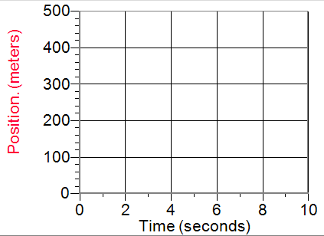



a) How fast is this plane moving?

b) What are the units of its velocity?



c) What is the equation of this line in y = mx +b form?



d) What is the **substituted** equation for this line?



12) The US Government recently acquired some secret alien UFO position-time test data. (Hint: even though the aliens use their own Martian units, apply what you know about slope to answer the questions.)

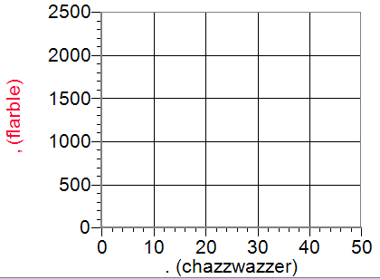



a) How fast is this UFO moving?

b) What are the units of its velocity?



c) What is the equation of this line in y = mx +b form?



d) What is the **substituted** equation for this line?



13) An up-and-coming CEO named Saul T. Gueb has started his own company, GuebCorp. Here are the company’s confidential pay scale files. To keep everything fair, Saul pays all employees based on how long they have worked there. Based on this graph:

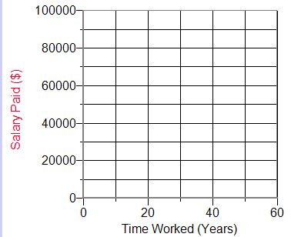

a) How much does a starting worker make there?



b) Assuming workers have to retire after 60 years of work, what is the maximum salary there?



c) How much of a raise do GuebCorp workers get each year (with units)?



d) What is the **substituted** equation for this line?



XC) Use your answer from 13d to calculate the salary (with units) of a worker who has been there for 37 years. Go to 2 decimal points.

